- Online Training:
A two days online training on ‘Socio Economic Baseline Survey’ for FNGOs, Documentation Expert & Livelihood Expert under DMU & FMU Head/Staffs was conducted by Project Management Unit, Kohima for all DMU’s on 29th & 30th April 2021. The Training was conducted by Mr. Shailesh Nagar (Monitoring & Evaluation Expert) PMC and Mr. Pravanjan Mohapatra (Capacity Building Expert) PMC.
The training was attended by all the DMU Heads, FMU Heads and staffs, Documentation Expert and Livelihood Expert of all the DMU’s. The Training was developed to extract ‘Socio Economic Survey’ in all the (NFMP) project villages to provide a benchmark on which the success of the project could be measured. The survey also aims to build a rapport with village community in a relatively short time period. All the participants actively took part during the two days training programme.
- Training for JFMC presidents and members & Demonstration on plantation technique:
One day hands on training and demonstration on plantations for different models was conducted on 7th May 2021 in the premises of the DMU Head office for the selected Batch-II villages. FMU Head Wokha briefed the meeting and gave the introductory note. FMU Heads Wokha & Doyang, DMU Staffs, FNGO members, Livelihood coordinator, Supervisor and JGMC members attended the training.
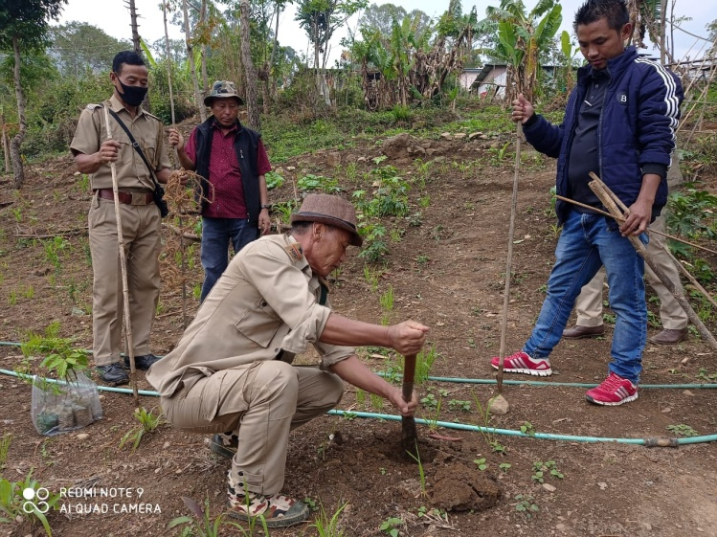
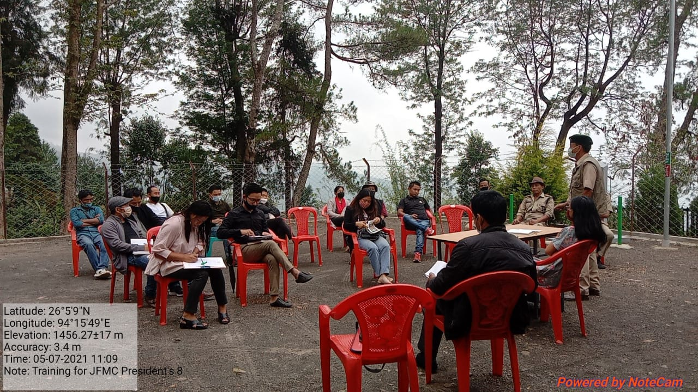

- Orientation Training for ADMU & FMU Heads
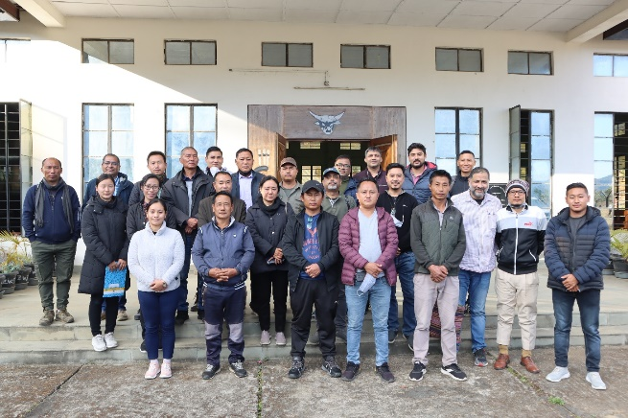
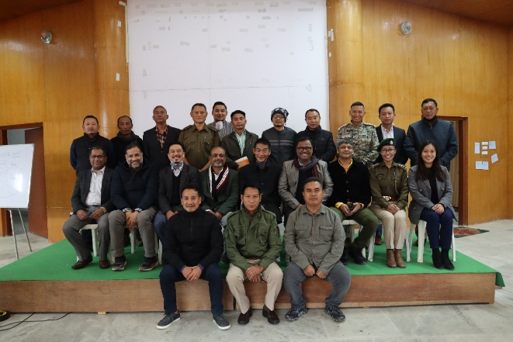
A three-day training for ADMU/FMU Heads under STC & NTC and review of implementation of NFMP under STC was held from 14th to 16th December 2021 at the Conference Hall of the Forest Office Complex, Kohima. The training was organized to sensitize the newly transferred and posted officials on the implementation of the NFMP and sharing and exchanging experiences about the project. The second day of the training was conducted at Zhadima ‘A’ village where ADMU Heads and FMU Heads of STC & NTC divided themselves into groups and proceeded with the group work. On the third day, FNGO review meeting of STC was held at the Conference Hall, where FNGO from Kohima, Phek, Dimapur, Peren and Wokha districts gave presentations on the key achievements, issues and challenges. PMC team members led by the team leader, Shri Pranab R. Choudhary, spoke on the role of FMU, DMU and FNGO in JFMC strengthening, Forestry Models and Livelihood promotion. In a brief address to the FNGO members, Shri Dharmendra Prakash, IFS Chief Project Director, NFMP exhorted the FNGO members to work with all sincerity for success in the implementation of the project

- Training of MIS Application
The PMU Office organised a Training of MIS Application for FNGO and DMU staffs on 25th - 26th November 2021 at the Conference Hall of the Forest Office Complex, Kohima. The 2-day training was conducted by the MIS cell on the topic - Financial and Forestry Module, Livelihood, EPA and WHS module.

- Field Orientation
Mon: One day Field Orientation for DMU & FNGO on IGA Identification and Preparation of Business Plan for Batch-I SHGs was conducted on 11th Oct. 2021 at Mon Village under Mon Division. Shri Pravanjan Mohapatra PMC, CB Expert briefed the FNGO and DMU staffs on the scope, importance and techniques of IGA and business plan formats. The FNGO members were divided into 3 groups in order to sit and discuss with each SHGs on their respective livelihood activities and find/discuss prospective opportunities in order to draw a proper IGA business plan. The FNGO and SHG members were assisted by DMU Support Staffs. The orientation program was attended by ADMU Head, DMU Support staffs, FMU staffs and members from all the selected SHGs under JFMC Mon village.
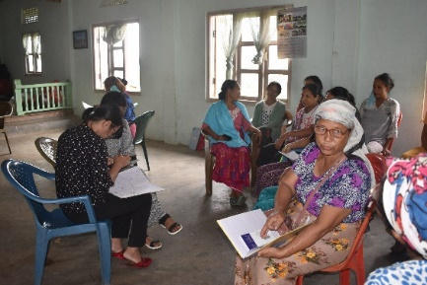
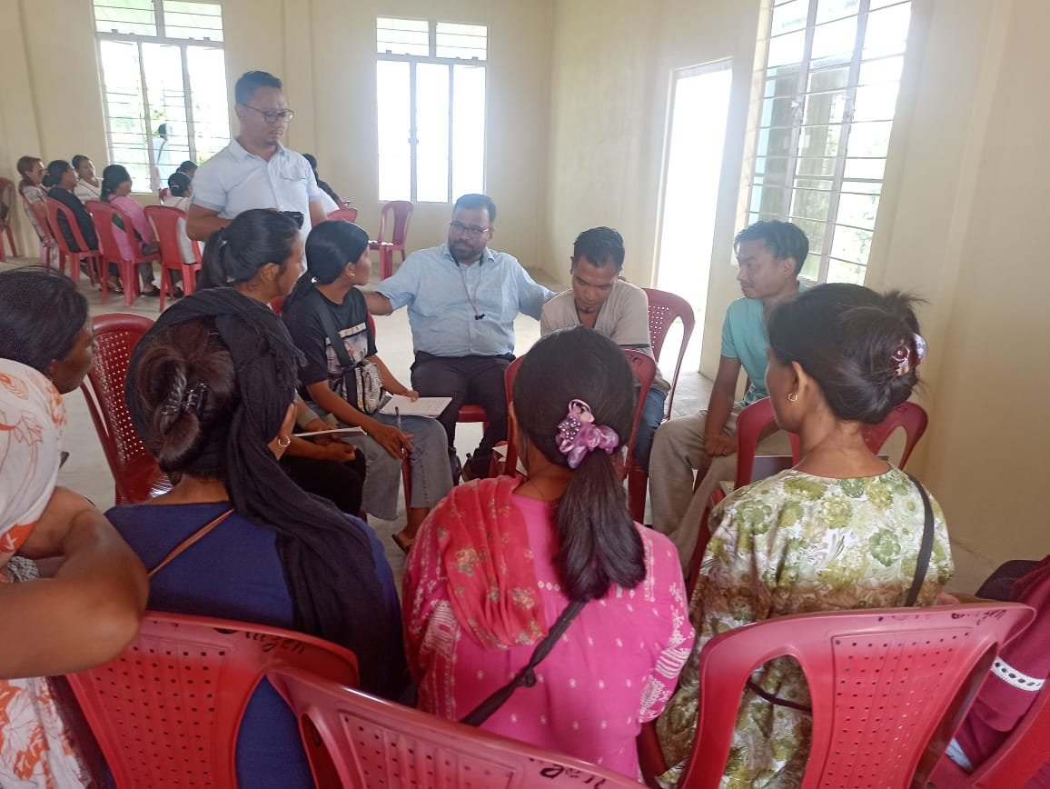

Phek: Field orientation for FNGO and DMU Support Staffs on IGA identification and Preparation of Business Plan for Batch-I villages under DMU-Phek was conducted on 6th Oct. at Kami Village. The orientation program was attended by the DMU Head Shri. Tepfuhusie IFS, Mr. Pravanjan Mohapatra PMC, DMU Support Staffs and Phek FNGO members along with Team Leader of FNGO Kiphire and the community mobilizers. The meeting was also attended by Kami Village JFMC members along with the selected SHGs.
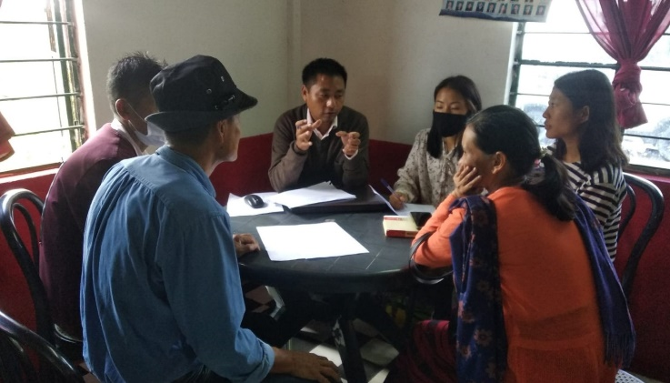
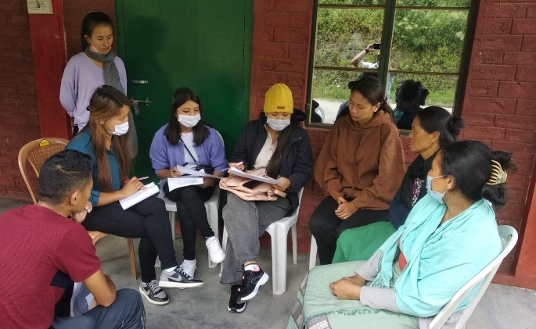
The participants were briefed on the process of Preparation of Business Plans, templates and short exercises were conducted with the SHGs. After the field exercises, participants were taken to JAF plantation site Kami as part of field exposure.

- Training on Nursery Demonstration
DMU Kohima conducted a Training on Nursery Demonstration on 17th November 2021 with the participation of Seiyhama, Phenwhenyu, Kandinu and Terogvunyu village JFMC members. T. Khel Model Village organized the event on the theme ‘Nursery Demonstration cum Workshop’.
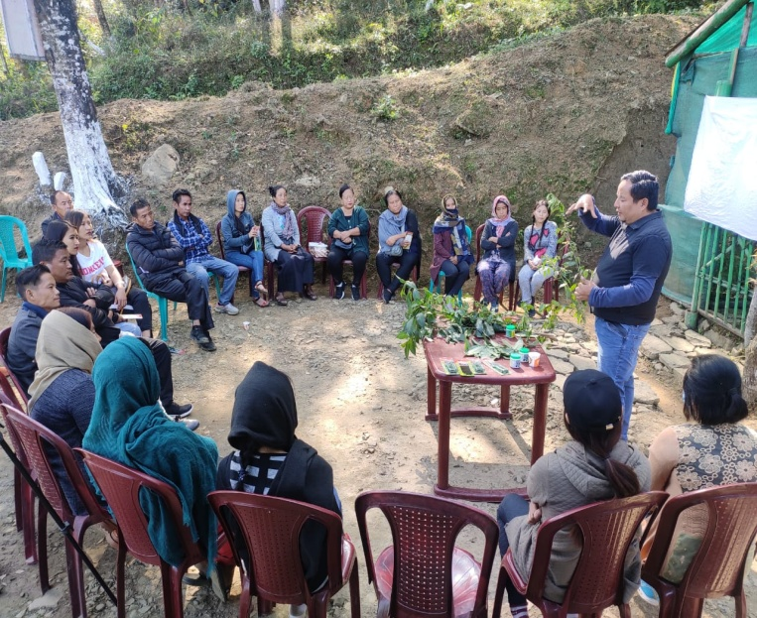
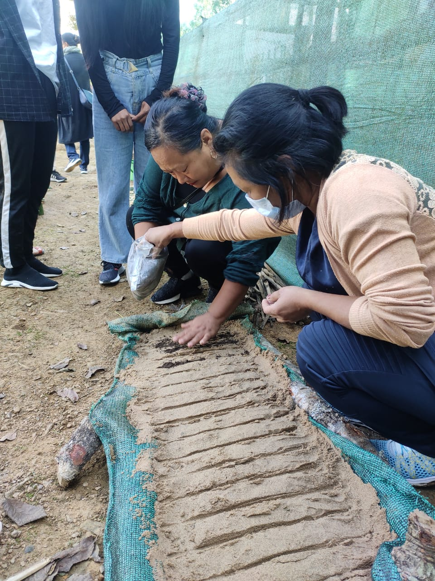
Delivering the keynote address Smti. Pezaneinuo Chielie, RFO Kohima highlighted that the importance of establishing a good nursery which is the basis of augmenting the rejuvenation of natural forests and ultimately for sustainable forest management of biodiversity in our tribal community. The demonstration emphasized on various planting medium, planting materials, methods of propagation, modern tools and inputs and environment friendly components of a nursery set up. All the participants had hands-on experience during the training.

Demonstration on planting techniques
Mini version of nursery bed preparation

